
Software Engineering Department

Braude College of Engineering

Final Project - Phase A (61998)

AI Agent for Clinic Operational Management

Amir Azulay | Amir.Azulay@e.braude.ac.il
Yovel Katz | Yovel.katz@e.braude.ac.il

Advisor:
Dr. Nataly Levi| Natalyl@braude.ac.il

GitHub Link:
https://github.com/AmirAzulay/AI-Agent-for-Clinic-Operational-Management

Table of Contents

Abstract 3
Part 1 - Introduction 4
Part 2 - Background and Related Work 5
Part 3 - Project Requirements 8
Part 4 - Research and Development Process 10
4.1 Research Phase 10
4.2 Development Methodology 10
4.3 AI Agent Design 10
4.4 AI Agent Workflow 11
4.5 AI Tools 11
4.6 Expected Outputs 12
4.7 Expected Challenges 13
4.7.1 Designing Realistic Clinic Simulations 13
4.7.2 Maintaining Explainable AI Decisions 13
4.7.3 Preventing Unnecessary or Incorrect Actions 13
4.7.4 Synchronizing Simulation and AI Analysis 14
4.7.5 Evaluating Agent Performance 14
4.7.6 Managing Project Scope 14
4.7.7 Ensuring Reliable Communication Between System Components 15
4.7.8 Maintaining Data Consistency 15
4.7.9 Designing a Clear and Useful Dashboard 15
4.7.10 Handling AI Output Reliability 16
4.7.11 Logging and Traceability of AI Actions 16
4.7.12 Balancing Automation and Human Control 16
4.8 Technologies and Tools 17
Part 5 - Diagrams (UC, Activity, Architecture) 18
Use Case Diagram: 18
Architecture Diagram: 18
Activity Diagram: 18

Abstract

**H**
Medical clinics operate in highly dynamic environments where patient arrivals, resource availability, and operational workloads continuously change throughout the day. These fluctuations can create operational bottlenecks, increase patient waiting times, and reduce the efficiency of resource utilization. Traditional clinic management systems primarily provide data displays and reports, but they lack the ability to understand operational context, identify emerging issues in real time, or proactively recommend corrective actions. As a result, clinic staff are required to manually monitor numerous metrics and dashboards, detect anomalies on their own, and make decisions under pressure and uncertainty. This approach can lead to delayed responses to problems, suboptimal resource allocation, and a strong dependence on the experience and availability of personnel.

This project proposes an AI-powered operational management system for a simulated medical clinic environment. The system combines a real-time clinic simulation with an AI Agent capable of analyzing operational conditions, identifying bottlenecks, detecting workload imbalances, and autonomously executing predefined management actions through a controlled Tool Calling architecture. The main idea of the proposed approach is the use of an autonomous AI agent that continuously observes the clinic state, reasons about operational conditions, and decides when and how to act. Unlike conventional rule-based dashboards or monitoring systems, the agent can combine information from multiple sources, understand the overall situation in the clinic, prioritize issues, and dynamically select appropriate actions. Instead of just displaying information, it functions as an intelligent management layer that transforms raw operational data into actionable decisions.

The use of an AI agent is particularly important because clinic operations involve many interconnected variables that change simultaneously. Human operators may overlook hidden patterns or emerging risks when monitoring multiple dashboards, especially during busy periods. An AI agent can continuously analyze the environment, detect trends before they become critical problems, and respond consistently according to predefined policies. This enables faster reaction times, reduces the pressure on staff, and supports more efficient and scalable operational management.

The proposed solution focuses on supporting operational decision-making and does not involve medical diagnosis. By monitoring patient queues, treatment room availability, physician workloads, and medication inventory levels, the AI agent can identify operational issues, generate alerts, initiate predefined corrective actions, and provide clear, explainable operational summaries for clinic staff and managers. The objective of this project is to demonstrate how AI Agent technologies can support the management and operation of healthcare systems through intelligent monitoring, controlled decision-making, and automated operational assistance. The expected outcome is improved clinic operational efficiency, reduced reliance on manual monitoring, optimized resource utilization, and enhanced ability to handle operational challenges within a simulated clinic environment. Furthermore, the project demonstrates how artificial intelligence can be integrated as an active operational mechanism rather than just a reporting tool, thereby reducing managerial workload, improving response times to events, and enabling staff to focus on higher-value tasks.

Part 1 - Introduction
Healthcare clinics operate in dynamic environments where patient arrivals, staff availability, treatment room occupancy, and operational resources continuously change throughout the day. Efficient management of these factors is essential for reducing waiting times, improving resource utilization, and maintaining service quality (AHRQ, n.d.; Varnosfaderani et al., 2024). Traditional clinic operations often rely on human personnel to monitor patient queues, identify overloaded departments, allocate resources, and respond to operational issues. As clinic complexity increases, this approach can lead to delayed responses, information overload, and inefficient decision-making (Nasef et al., 2025; Varnosfaderani et al., 2024).

Healthcare organizations commonly use Healthcare Information Systems (HIS), Electronic Health Record (EHR) platforms, and Clinic Management Systems (CMS) to support administrative and clinical workflows. Systems such as Epic, Oracle Health, and athenaOne provide capabilities including patient registration, appointment scheduling, medical record management, resource tracking, reporting, and operational coordination (Epic, n.d.; Oracle, n.d.; athenahealth, n.d.). While these platforms improve data accessibility and workflow management, they primarily focus on collecting, organizing, and presenting information. The responsibility for interpreting operational conditions and determining appropriate responses generally remains with human operators (Epic, n.d.; Oracle, n.d.; athenahealth, n.d.).

Recent advances in Artificial Intelligence have expanded the use of intelligent decision-support systems within healthcare environments. AI technologies have demonstrated potential in operational areas such as patient flow optimization, scheduling support, workforce management, administrative automation, and resource allocation (Bhagat et al., 2024; Nasef et al., 2025; Varnosfaderani et al., 2024). Unlike traditional software systems, AI Agents can analyze complex situations, reason about operational conditions, and select actions through interactions with predefined tools (Yao et al., 2022; Schick et al., 2023). Research on ReAct and Toolformer demonstrates how language models can combine reasoning with action execution and make effective use of external tools to solve operational tasks (Yao et al., 2022; Schick et al., 2023).

Simulation is widely used for evaluating healthcare processes because it enables the study of dynamic environments without relying on real patient data. Discrete-event simulation is commonly applied to represent patient arrivals, queue formation, treatment durations, room occupancy, and resource utilization in healthcare settings (Vázquez-Serrano et al., 2021; Forbus & Berleant, 2022). Simulation environments provide a safe and repeatable way to create operational scenarios such as department overload, long waiting times, medication shortages, and resource constraints, making them suitable for evaluating AI-driven operational management systems (Forbus & Berleant, 2022; Vázquez-Serrano et al., 2021).

The proposed project combines these concepts by developing an AI-powered operational management system for a simulated clinic environment. The system utilizes an AI Agent that continuously monitors operational conditions, identifies bottlenecks, and performs predefined management actions through a controlled tool-calling architecture. The agent is restricted to operational decision support and does not perform medical diagnosis or treatment recommendations, following recommendations for safe and explainable healthcare AI systems (WHO, 2021). By integrating simulation, operational monitoring, AI reasoning, and controlled tool execution, the project aims to bridge the gap between traditional clinic management systems that primarily display information and intelligent systems capable of providing proactive operational assistance (Yao et al., 2022; Schick et al., 2023; WHO, 2021).

Part 2 - Background and Related Work
2.1 Healthcare Operational Management and Patient Flow
Healthcare clinics operate in dynamic environments where patient arrivals, waiting queues, treatment rooms, medical staff, and operational resources continuously change throughout the day. Efficient operational management is essential for maintaining acceptable waiting times, reducing congestion, improving patient satisfaction, and maximizing resource utilization. Patient flow is influenced by multiple factors, including arrival rates, treatment duration, room availability, physician workload, department capacity, urgency levels, and administrative processes (Varnosfaderani et al., 2024; Nasef et al., 2025).

Traditionally, clinic operations rely heavily on human personnel to monitor queues, track resource availability, identify bottlenecks, and respond to operational issues. Reception staff, nurses, and managers are often required to monitor multiple data sources simultaneously while making decisions under time pressure. Although this approach may be effective in smaller clinics, it becomes increasingly difficult as patient volume and operational complexity grow. Delayed responses, information overload, and inefficient resource allocation may negatively impact clinic performance and patient satisfaction (Nasef et al., 2025; Varnosfaderani et al., 2024).

Recent research shows that artificial intelligence is increasingly being applied not only to clinical diagnosis but also to healthcare operations. AI technologies are being used to improve scheduling, patient flow management, workforce planning, and resource allocation (Bhagat et al., 2024; Varnosfaderani et al., 2024). These developments demonstrate the growing interest in intelligent operational support systems within healthcare environments.

2.2 Existing Healthcare Management Systems
Healthcare organizations commonly use Healthcare Information Systems (HIS), Electronic Health Record (EHR) platforms, and Clinic Management Systems (CMS) to support daily clinical and administrative workflows. These systems provide functionality such as patient registration, appointment scheduling, medical record management, billing, reporting, communication between healthcare staff, and resource tracking (Epic Systems, n.d.; Oracle, n.d.; athenahealth, n.d.).

Several commercial platforms are widely adopted throughout the healthcare industry. Epic Systems provides a comprehensive healthcare platform centered around patient records and operational workflows. Oracle Health offers tools for patient flow management, resource utilization, length-of-stay monitoring, discharge coordination, and operational visibility. Similarly, athenaOne provides an integrated cloud-based platform that combines EHR functionality, medical billing, patient engagement, and practice management capabilities (Epic Systems, n.d.; Oracle, n.d.; athenahealth, n.d.).

Although these systems significantly improve information accessibility and workflow coordination, they primarily focus on collecting, organizing, and presenting operational data. In most cases, healthcare personnel remain responsible for interpreting information, identifying operational problems, and deciding which actions should be taken. Consequently, there remains a gap between information management systems and intelligent systems capable of actively supporting operational decision-making.

The proposed project addresses this gap by introducing an AI Agent that continuously monitors clinic conditions, analyzes operational situations, and performs predefined actions through a controlled tool-calling architecture. Rather than functioning solely as a reporting system, the proposed solution provides proactive operational support.

2.3 Artificial Intelligence in Healthcare Operations
Artificial Intelligence has become an important research area in healthcare. While many AI applications focus on medical diagnosis, disease prediction, medical imaging, and clinical risk assessment, AI is increasingly being used for operational and administrative tasks (Bhagat et al., 2024; Nasef et al., 2025).

AI-based operational systems can process large volumes of data and identify patterns that may be difficult for human operators to detect in real time. For example, AI can detect increasing waiting times, identify overloaded departments, recognize resource shortages, and support scheduling decisions. Such capabilities allow healthcare organizations to improve responsiveness, reduce manual workload, and optimize resource utilization (Varnosfaderani et al., 2024; Bhagat et al., 2024).

Nasef et al. (2025) discuss the integration of AI into hospital management and healthcare operations, highlighting opportunities for workforce planning, capacity management, and operational optimization. Similarly, Varnosfaderani et al. (2024) describe the growing role of AI in improving hospital efficiency, administrative workflows, patient flow, and scheduling processes.

In the context of this project, AI is not used to replace healthcare professionals or perform medical diagnosis. Instead, the AI Agent is restricted to operational decision support. The agent analyzes clinic conditions such as patient queues, waiting times, room availability, physician workload, department status, and medication inventory. Based on this information, it can identify operational bottlenecks, generate alerts, and initiate predefined actions designed to improve clinic efficiency.

2.4 Simulation-Based Healthcare Management
Simulation is widely used for analyzing and improving healthcare systems because healthcare environments are complex, dynamic, and difficult to evaluate directly in real-world settings. Discrete-event simulation (DES) is one of the most common approaches used for modeling healthcare operations because it can represent patient arrivals, waiting queues, treatment durations, room occupancy, and resource utilization (Vázquez-Serrano et al., 2021; Forbus & Berleant, 2022).

Forbus and Berleant (2022) reviewed the use of discrete-event simulation in healthcare and demonstrated its application in healthcare operations, capacity planning, patient flow management, and resource allocation. Similarly, Vázquez-Serrano et al. (2021) describe DES as an effective approach for evaluating complex healthcare processes and testing operational improvements before implementation.

Simulation is particularly suitable for this project because it enables realistic testing without relying on real patient data. A simulated clinic environment can generate controlled scenarios such as department overload, long waiting times, medication shortages, physician overload, and resource constraints. These scenarios provide a safe environment for evaluating AI-driven operational decision-making while avoiding privacy, safety, and ethical concerns associated with real healthcare systems.

An additional advantage of simulation is repeatability. The same operational scenario can be executed multiple times, allowing the behavior of the AI Agent to be tested, evaluated, and improved under controlled conditions.

2.5 AI Agents, Tool Calling, and System Safety
AI Agents represent an evolution beyond traditional chatbots and monitoring systems. While conventional systems primarily provide information or textual responses, AI Agents can reason about situations, determine appropriate actions, and interact with external tools to achieve operational goals.

The ReAct framework introduced by Yao et al. (2022) combines reasoning and acting within language models. Instead of generating a single response, the model can analyze a situation, decide on an action, execute that action, and continue reasoning based on the results. This approach improves transparency, adaptability, and decision-making capabilities.

Toolformer extends this concept by demonstrating how language models can learn to use external tools and APIs when necessary (Schick et al., 2023). Rather than relying only on internal knowledge, the model can access external functions, retrieve information, and perform structured actions through predefined interfaces.

These concepts are directly relevant to the proposed project. The clinic management system adopts a controlled tool-calling architecture in which the AI Agent continuously analyzes clinic conditions and selects actions using predefined backend tools. Examples include reading clinic status, opening inactive treatment rooms, creating alerts, updating department status, requesting medication restocking, and generating operational summaries.

A key design principle is the separation between reasoning and execution. The AI Agent determines which action should be performed, while the backend controls how the action is executed. This architecture improves safety, transparency, maintainability, and system reliability because all actions can be validated, monitored, and logged before execution (Yao et al., 2022; Schick et al., 2023).

Healthcare-related AI systems must also address explainability, safety, and human oversight. The World Health Organization emphasizes that AI systems in healthcare should be transparent, accountable, safe, and designed to support human decision-makers rather than replace them (WHO, 2021).

For this reason, the proposed system limits the AI Agent to predefined operational actions only. The agent cannot diagnose diseases, recommend treatments, prescribe medications, or modify clinical records. All actions are logged and accompanied by explanations that describe why the action was performed. This approach supports transparency, enables human review, and helps build trust in the system while maintaining safe operational boundaries (WHO, 2021).

Part 3 - Project Requirements

FR | NFR
The system shall simulate patient arrivals at predefined time intervals during the clinic working day. | The dashboard shall provide a clear and intuitive user interface.
The system shall create and maintain patient records during the simulation. | The system shall display clinic information in an organized and readable manner.
The system shall store patient information including department assignment, urgency level, waiting time, and treatment status. | The system shall update operational information with minimal delay during the simulation.
The system shall assign each patient to a relevant clinic department according to predefined simulation rules. | System operations and AI actions shall be consistently recorded.
The system shall support multiple clinic departments such as general medicine, pediatrics, orthopedics, and emergency care. | The AI Agent shall provide explanations for all executed actions.
The system shall manage clinic departments and their operational states. | AI Agent explanations shall be understandable to non-technical users.
The system shall maintain the operational status of each department, such as Normal, Warning, Overloaded, and Critical. | Access to the system shall be restricted to authorized users.
The system shall track the number of patients waiting in each department queue. | The system shall support user authentication for accessing the dashboard.
The system shall calculate and update patient waiting time throughout the simulation. | The system shall protect operational data from unauthorized access.
The system shall manage treatment rooms and room availability. | The architecture shall support future expansion and modification.
The system shall track whether each treatment room is available, occupied, inactive, or under maintenance. | Additional departments, rooms, doctors, medications, and users shall be supported without major redesign.
The system shall allow inactive treatment rooms to be opened when overload conditions are detected. | The system shall allow simulation parameters to be modified without changing the core architecture.
The system shall track doctor availability for each department. | The system shall be modular and separate the dashboard, backend, database, simulation engine, and AI Agent components.
The system should track doctor's workload according to assigned patients and active treatments. | The backend shall expose structured APIs for communication between system components.
The system shall manage medication inventory levels. | The system shall store data in a structured and consistent database format.
The system shall detect low medication inventory when stock falls below a predefined threshold. | The system shall maintain reliable operation during continuous clinic simulation.
The system shall generate medication restock requests when medication inventory is low. | The system should provide consistent response formats for backend API responses.
The system shall generate operational alerts when abnormal situations occur. | The AI Agent shall be restricted to predefined operational tools only.
The system should generate alerts for long waiting times, department overload, room shortage, doctor overload, and medication shortage. | The AI Agent shall not perform medical diagnosis or treatment recommendations.
The system should provide a dashboard for clinic monitoring. | The system shall log errors and important events for debugging and evaluation.
The dashboard shall display patient queues, department statuses, room availability, doctor workload, medication inventory, and active alerts. | The system shall support integration testing between the dashboard, backend, database, simulation engine, and AI Agent.
The system allows authorized users to activate the AI Agent. | The system should be maintainable and understandable for future development.
The AI Agent shall read the current clinic state before making operational decisions. | The system shall provide stable performance under predefined simulated clinic workloads.
The AI Agent shall analyze clinic conditions and identify operational bottlenecks. | The system shall be containerization-ready to support future deployment using Docker.
The AI Agent shall select predefined operational tools according to the detected clinic condition. | The system should be designed to allow future integration with external clinic management systems.
The AI Agent shall be able to create operational alerts through a controlled backend tool.
The AI Agent shall be able to update department status through a controlled backend tool.
The AI Agent shall be able to open an inactive treatment room through a controlled backend tool.
The AI Agent shall be able to generate medication restock requests through a controlled backend tool.
The AI Agent shall generate an operational summary describing the current clinic state, detected problems, and performed actions.

Part 4 - Research and Development Process

4.1 Research Phase
The research phase will focus on studying:
- AI Agent architectures
- Tool-calling frameworks
- Decision-support systems
- Healthcare operational management systems
- Simulation-based management environments
Relevant academic papers, technical documentation, and industry solutions will be reviewed in order to define the system architecture and project scope.

4.2 Development Methodology
The project will be developed incrementally using an Agile development approach.
Development will proceed through the following stages:
- Requirements analysis
- Database design
- Backend implementation
- Clinic simulation implementation
- Dashboard development
- AI Agent implementation
- Integration testing
- System evaluation

4.3 AI Agent Design
The AI Agent represents the core component of the project.
Unlike a traditional chatbot, the agent is designed as an operational AI system capable of using predefined tools to perform actions within the clinic environment.
The AI Agent will receive:
- Patient queues
- Waiting times
- Department statuses
- Room availability
- Doctor availability
- Medication inventory
- Active alerts

4.4 AI Agent Workflow
The AI Agent performs the following sequence:

Step 1 - Read Clinic State
The agent retrieves the complete operational state of the clinic.

Step 2 - Analyze Conditions
The agent identifies operational bottlenecks such as:
- Department overload
- Long waiting times
- Room shortages
- Medication shortages

Step 3 - Select Tools
The agent determines which operational tools should be activated.

Step 4 - Execute Actions
Selected tools are executed through the backend system.

Step 5 - Generate Summary
The agent generates a summary describing detected problems and executed actions.

4.5 AI Tools
- AI models from Claude/OpenAI/Gemini
- Function Calling mechanisms
- Structured JSON outputs
- Prompt engineering techniques
The AI Agent will be able to use the following operational tools:

Tool | Description
READ_CLINIC_STATE | Retrieves the complete operational state of the clinic.
OPEN_ROOM | Activates inactive treatment rooms.
CREATE_ALERT | Creates operational alerts.
SET_DEPARTMENT_STATUS | Updates department operational status.
REQUEST_MEDICATION_RESTOCK | Generates medication restocking requests.
GENERATE_SUMMARY | Produces operational summaries and reports.

4.6 Expected Outputs
The proposed system is expected to generate several outputs that support operational decision-making and clinic management:
- Operational Alerts - Real-time notifications for situations such as department overload, long waiting times, room shortages, and low medication inventory.
- Department Status Updates - Dynamic classification of departments based on their current operational condition (e.g., Normal, Warning, Overloaded, Critical).
- AI Action Logs - Detailed records of all actions performed by the AI Agent, including the reason for each decision and its outcome.
- Medication Restock Requests - Automatic requests generated when medication inventory falls below predefined thresholds.
- Operational Summaries - AI-generated summaries describing clinic conditions, detected issues, and actions performed.

4.7 Expected Challenges
Several challenges are anticipated during the development of the proposed system. Since the project combines clinic simulation, real-time operational monitoring, backend services, a database, a dashboard, and an AI Agent, the main challenges are related to realism, synchronization, decision quality, explainability, evaluation, and project scope.

4.7.1 Designing Realistic Clinic Simulations
One of the main challenges in this project is designing a clinic simulation that is realistic enough to represent the operational behavior of a real clinic. The simulation needs to include patient arrivals, department queues, treatment rooms, doctor availability, medication inventory, waiting times, and changing workload conditions throughout the working day.
The difficulty is that real clinics are dynamic and unpredictable. Patients may arrive at different rates, some departments may become overloaded faster than others, and treatment duration may vary depending on urgency level or department type. Therefore, the simulation should not be too simple, because an overly basic simulation would not provide meaningful scenarios for testing the AI Agent.
At the same time, the simulation should not be too complex, because the goal of the project is to demonstrate operational AI decision support rather than fully reproduce every detail of a real medical environment. The challenge is to find a balanced level of realism that allows the system to create useful scenarios such as long waiting times, room shortages, doctor overload, department congestion, and medication shortages.

4.7.2 Maintaining Explainable AI Decisions
Another important challenge is ensuring that the AI Agent provides clear and understandable explanations for every action it performs. Since the system operates in a healthcare-related environment, users must be able to understand why a specific action was taken.
For example, if the AI Agent opens an inactive treatment room, it should not only execute the action but also explain the reason behind it. A good explanation may include the current department status, the number of waiting patients, the average waiting time, and the availability of inactive rooms. Without such explanations, users may not trust the system or may find it difficult to evaluate the correctness of the agent’s decisions.
The challenge is to generate explanations that are both accurate and simple enough for non-technical users. The explanations should avoid unnecessary technical language and focus on operational reasoning. This is especially important for clinic managers, reception staff, and medical staff who need practical and understandable information.

4.7.3 Preventing Unnecessary or Incorrect Actions
A central challenge in the project is preventing the AI Agent from performing unnecessary, repeated, or inappropriate actions. Since the agent can activate operational tools, it must be restricted to safe and relevant decisions only.
For example, the AI Agent should not open a new treatment room if the department is not overloaded. It should not repeatedly create the same alert if the problem has already been reported. It should not request medication restocking if the inventory level is still above the predefined threshold. It should also avoid performing multiple actions when one action is sufficient.
To address this challenge, the system must define clear rules, thresholds, and constraints for each tool. The AI Agent should be able to use only predefined operational tools, and each action should be validated by the backend before execution. This ensures that the agent’s decisions remain controlled, predictable, and aligned with the system requirements.

4.7.4 Synchronizing Simulation and AI Analysis
The system includes a simulation engine that continuously updates the clinic state, while the AI Agent analyzes this state and decides whether an action is needed. A major challenge is ensuring that the agent always works with the most up-to-date clinic information.
If the AI Agent analyzes outdated data, it may make incorrect decisions. For example, the agent may decide to open a treatment room based on an old queue length, even though the queue has already decreased. Similarly, it may create an alert for a medication shortage after the inventory has already been restocked.
Therefore, synchronization between the simulation engine, database, backend, dashboard, and AI Agent is essential. The system must ensure that clinic state updates are stored consistently and that the AI Agent reads the current state before making decisions. This challenge becomes more significant as the simulation becomes more dynamic and the number of system components increases.

4.7.5 Evaluating Agent Performance
Evaluating the AI Agent’s performance is another major challenge. Unlike traditional software functions, where the output is often clearly correct or incorrect, AI-generated decisions may require more careful evaluation. The project must define objective criteria for measuring whether the agent behaves effectively.
Possible evaluation metrics include the number of correctly detected overload situations, the number of appropriate actions performed, the reduction in average waiting time, the reduction in department overload duration, the number of unnecessary actions avoided, and the quality of generated explanations.
For example, if a department becomes overloaded, the system should measure whether the AI Agent identified the overload, selected the correct tool, executed the action at the right time, and provided a clear explanation. The challenge is to create test scenarios where the expected behavior is known in advance, so the agent’s decisions can be compared against predefined expected outcomes.

4.7.6 Managing Project Scope
The project involves several different components: a clinic simulation, backend APIs, a database, a dashboard, authentication, an AI Agent, tool-calling logic, logging, and evaluation. Managing the scope of the project is therefore an important challenge.
There is arisk of trying to implement too many features within the available development time. For example, adding advanced scheduling algorithms, real hospital integrations, complex medical workflows, or advanced prediction models may increase the complexity beyond the scope of a final project.
To manage this challenge, the project should focus on a clear and achievable prototype. The main goal is to demonstrate how an AI Agent can support clinic operational management in a simulated environment. Therefore, the project should prioritize the core workflow: simulate clinic activity, display operational data, allow the AI Agent to read the clinic state, detect bottlenecks, execute predefined tools, and generate explanations.

4.7.7 Ensuring Reliable Communication Between System Components
Because the system is modular, different components need to communicate reliably with each other. The dashboard communicates with the backend, the backend communicates with the database, the simulation updates the clinic state, and the AI Agent uses backend tools to execute actions.
A challenge may occur if one component updates data while another component reads old or incomplete information. Another challenge may occur if API responses are inconsistent or if one service fails during the simulation. These issues can affect the correctness of the dashboard and the decisions made by the AI Agent.
To reduce this risk, the backend should expose structured API endpoints with consistent response formats. Important operations should be logged, and errors should be handled clearly. This will make the system easier to debug and will support integration testing between the different components.

4.7.8 Maintaining Data Consistency
The database is expected to store several types of operational data, including patients, departments, rooms, doctors, medication inventory, alerts, and AI action logs. A challenge may arise when multiple entities depend on each other.
For example, when a patient is moved from waiting to treatment, the patient status, department queue, doctor workload, and room availability may all need to be updated. If only some of these values are updated correctly, the clinic state may become inconsistent. This can lead to incorrect dashboard information and wrong AI decisions.
To address this challenge, the data model should be designed carefully. Each entity should have a clear structure, and state transitions should be handled through backend logic rather than direct uncontrolled updates. This will help maintain reliable and consistent clinic data throughout the simulation.

4.7.9 Designing a Clear and Useful Dashboard
The dashboard is the main interface between the system and its users. It must present operational information in a way that is clear, organized, and easy to understand. Since the system tracks many types of data, there is a risk that the dashboard will become overloaded with too much information.
The challenge is to display the most important information without making the interface confusing. The dashboard should clearly show patient queues, department statuses, room availability, doctor workload, medication inventory, active alerts, and AI Agent actions. Visual indicators such as statuses, tables, alerts, and summaries can help users quickly understand the clinic condition.
The dashboard should also show the AI Agent’s explanations in a visible and readable way. This is important because users need to understand not only what happened, but also why the agent performed a specific action.

4.7.10 Handling AI Output Reliability
AI models may sometimes generate unclear, incomplete, or unexpected outputs. Since the proposed system uses the AI Agent for operational decision support, the system must ensure that AI outputs are structured and safe to use.
For example, if the AI Agent is expected to choose one of several predefined tools, the output should match the required format. The agent should not invent new tools, perform actions outside its permission scope, or return unstructured text when a structured decision is required.
To handle this challenge, the system should use structured outputs, predefined tool schemas, validation rules, and backend-side checks. The backend should verify that the requested tool exists, that the arguments are valid, and that the action is allowed under the current clinic state. This ensures that the AI Agent remains controlled and predictable.

4.7.11 Logging and Traceability of AI Actions
Since the AI Agent performs operational actions, the system must record what actions were taken, when they were taken, and why. Logging is important for debugging, evaluation, and user trust.
For every AI action, the system should store relevant information such as the clinic state at the time of decision, the detected problem, the selected tool, the executed action, and the explanation generated by the agent. Without this information, it may be difficult to understand whether the agent behaved correctly.
The challenge is to design logs that are detailed enough for evaluation but not too complex to manage. These logs can later be used to analyze the agent’s performance, detect repeated mistakes, and improve the decision-making logic.

4.7.12 Balancing Automation and Human Control
Although the system includes an AI Agent, it should not remove human responsibility from clinic operations. A key challenge is deciding which actions can be automated and which actions should require human review or approval.
For example, creating an alert or generating a summary may be safe to automate. Opening an inactive treatment room may also be allowed under predefined conditions. However, more sensitive decisions should remain outside the agent’s scope, especially anything related to medical diagnosis, treatment recommendations, or clinical decision-making.
The proposed system should therefore maintain a controlled level of automation. The AI Agent should support clinic staff, not replace them. Human users should be able to view the agent’s actions, understand its explanations, and remain in control of the operational process.

4.8 Technologies and Tools

Component | Technology
Frontend | React
Backend | FastAPI (Python)
Database | AWS Aurora PostgreSQL
AI Integration | OpenAI/Claude/Gemini Models
API Communication | REST APIs
Version Control | Git & GitHub
Containerization | Docker

Part 5 - Diagrams (UC, Activity, Architecture)

Use Case Diagram:

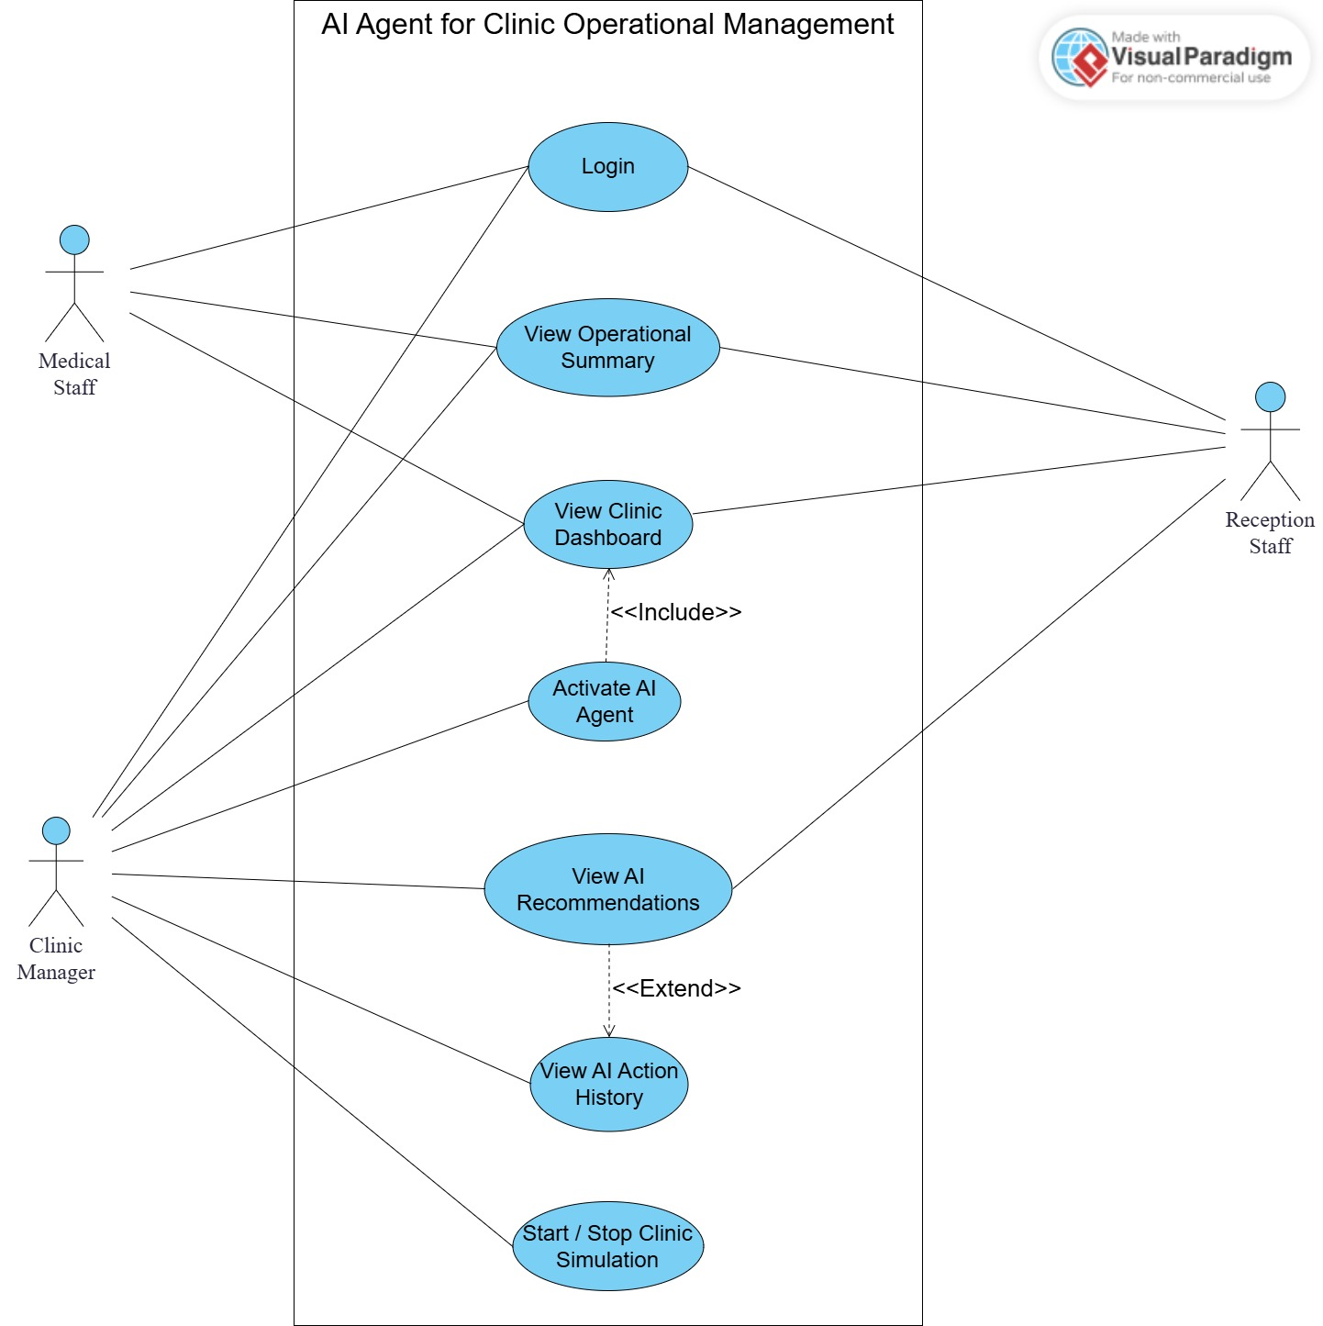

Architecture Diagram:
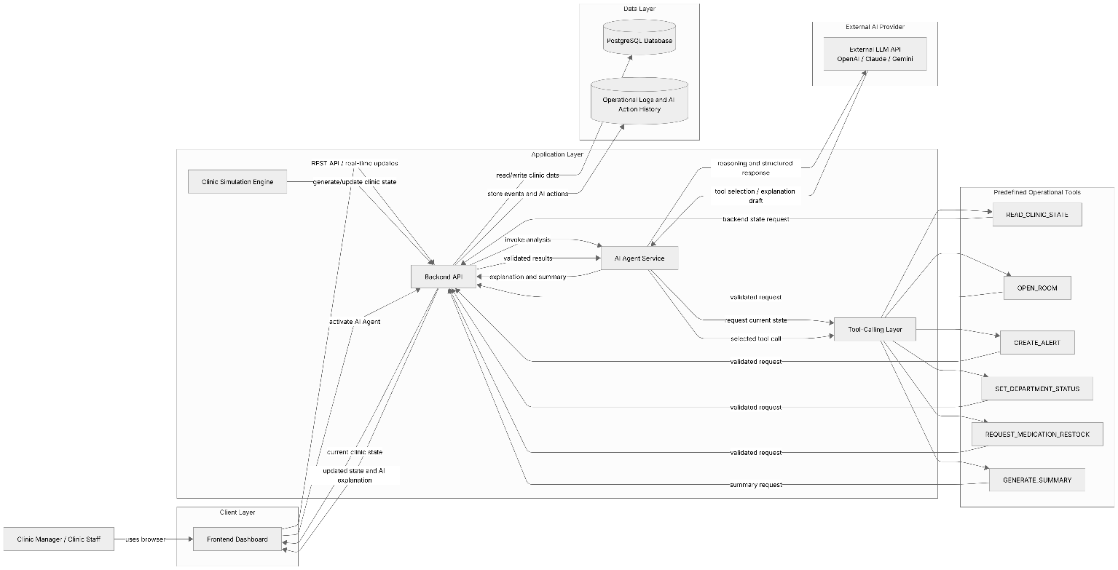

Activity Diagram:

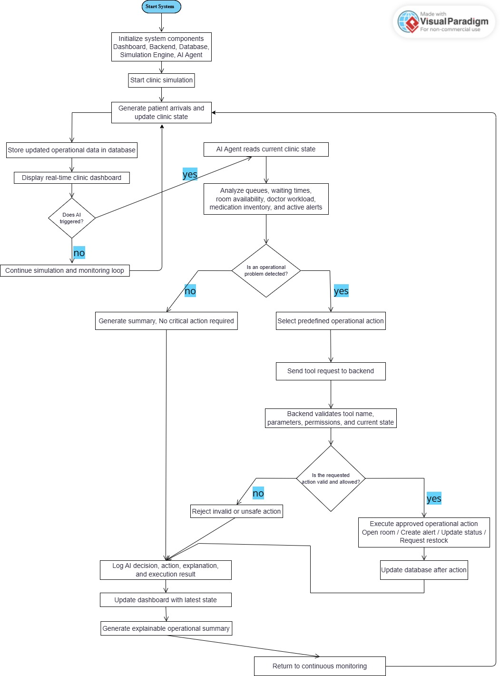

VERIFICATION:

References

- Agency for Healthcare Research and Quality. (n.d.). Agency for Healthcare Research and Quality.

- athenahealth. (n.d.). athenaOne: EHR, medical billing, practice management, and patient engagement.

- Bhagat, S. V., et al. (2024). Navigating the future: The transformative impact of artificial intelligence on hospital management.

- Docker. (n.d.). What is a container? Docker documentation.

- Epic Systems. (n.d.). Epic: With the patient at the heart.

- Epic Systems. (n.d.). Hospital patient flow.

- FastAPI. (n.d.). FastAPI documentation.

- Forbus, J. J., & Berleant, D. (2022). Discrete-event simulation in healthcare settings: A review.

- Nasef, D., et al. (2025). Integrating artificial intelligence in clinical practice, hospital management, and healthcare operations.

- Oracle. (n.d.). Clinical Operations | Oracle Health.

- PostgreSQL Global Development Group. (n.d.). JSON types. PostgreSQL documentation.

- React. (n.d.). React documentation.

- Schick, T., Dwivedi-Yu, J., Dessì, R., Raileanu, R., Lomeli, M., Zettlemoyer, L., Cancedda, N., & Scialom, T. (2023). Toolformer: Language Models Can Teach Themselves to Use Tools.

- Varnosfaderani, S. M., et al. (2024). The role of AI in hospitals and clinics: Transforming healthcare in the 21st century.

- Vázquez-Serrano, J. I., Peimbert-García, R. E., & Cárdenas-Barrón, L. E. (2021). Discrete-event simulation modeling in healthcare: A comprehensive review.

- World Health Organization. (2021). Ethics and governance of artificial intelligence for health.

- Yao, S., Zhao, J., Yu, D., Du, N., Shafran, I., Narasimhan, K., & Cao, Y. (2022). ReAct: Synergizing Reasoning and Acting in Language Models.

